**Pizza Sales SQL Quries**

KPI’s REQUIREMENT.

* SELECT SUM(total_price) AS [Total Revenue] FROM pizza_sales



* select sum(total_price)/count(Distinct(order_id)) as [Avg Sales] from pizza_sales

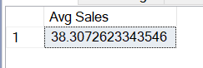

* select SUM(quantity) as [Total Pizza sold] from pizza_sales

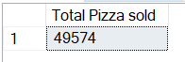

* select count(DISTINCT(order_id)) AS [Total Order Placed] from pizza_sales

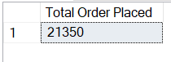

* select cast(convert(decimal(10,2), sum((quantity)))/convert(decimal(10,2), COUNT(Distinct(order_id))) AS decimal(10,2) ) as [Average Pizza Per Order] from pizza_sales

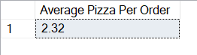

CHARTS’s REQUIREMENT.

* SELECT DATENAME(DW, order_date) as [Order Day], count(distinct(order_id)) as [Total Order] FROM pizza_sales group by DATENAME(DW, order_date)

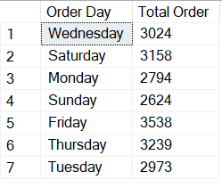

* SELECT DATENAME(MONTH, order_date) as [Month Name], count(distinct(order_id)) as [Total Order] FROM pizza_sales group by DATENAME(MONTH, order_date)

order by [Total Order] desc

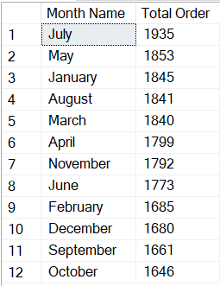

* select pizza_category, sum(total_price) as [Total Sales], SUM(total_price) * 100 / (select SUM(total_price) from pizza_sales where MONTH(order_date) = 1 ) as [% Total Sales] from pizza_sales

where MONTH(order_date) = 1 -- Month of 'January'

group by pizza_category

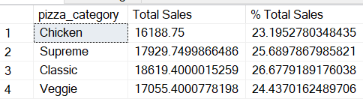

* select pizza_size, Cast(sum(total_price) AS decimal(10, 2)) as [Total Sales] , Cast(SUM(total_price) * 100 / (select SUM(total_price) from pizza_sales) AS decimal(10, 2)) as [% Total Sales] from pizza_sales

group by pizza_size

order by [% Total Sales] desc

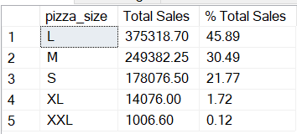

* select top 5 pizza_name, SUM(total_price) as [Total revenue] from pizza_sales

group by pizza_name

order by [Total revenue] desc

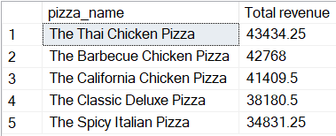

* select top 5 pizza_name, SUM(total_price) as [Total revenue] from pizza_sales

group by pizza_name

order by [Total revenue]

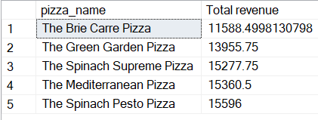

* select top 5 pizza_name, SUM(quantity) as [Total Quantity] from pizza_sales

group by pizza_name

order by [Total Quantity] asc

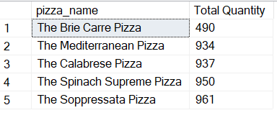

* select top 5 pizza_name, COUNT(Distinct(order_id)) as [Total Order] from pizza_sales

group by pizza_name

order by [Total Order] asc

